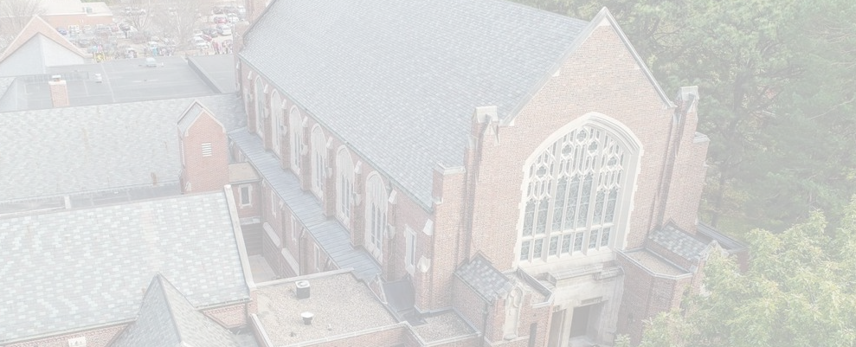
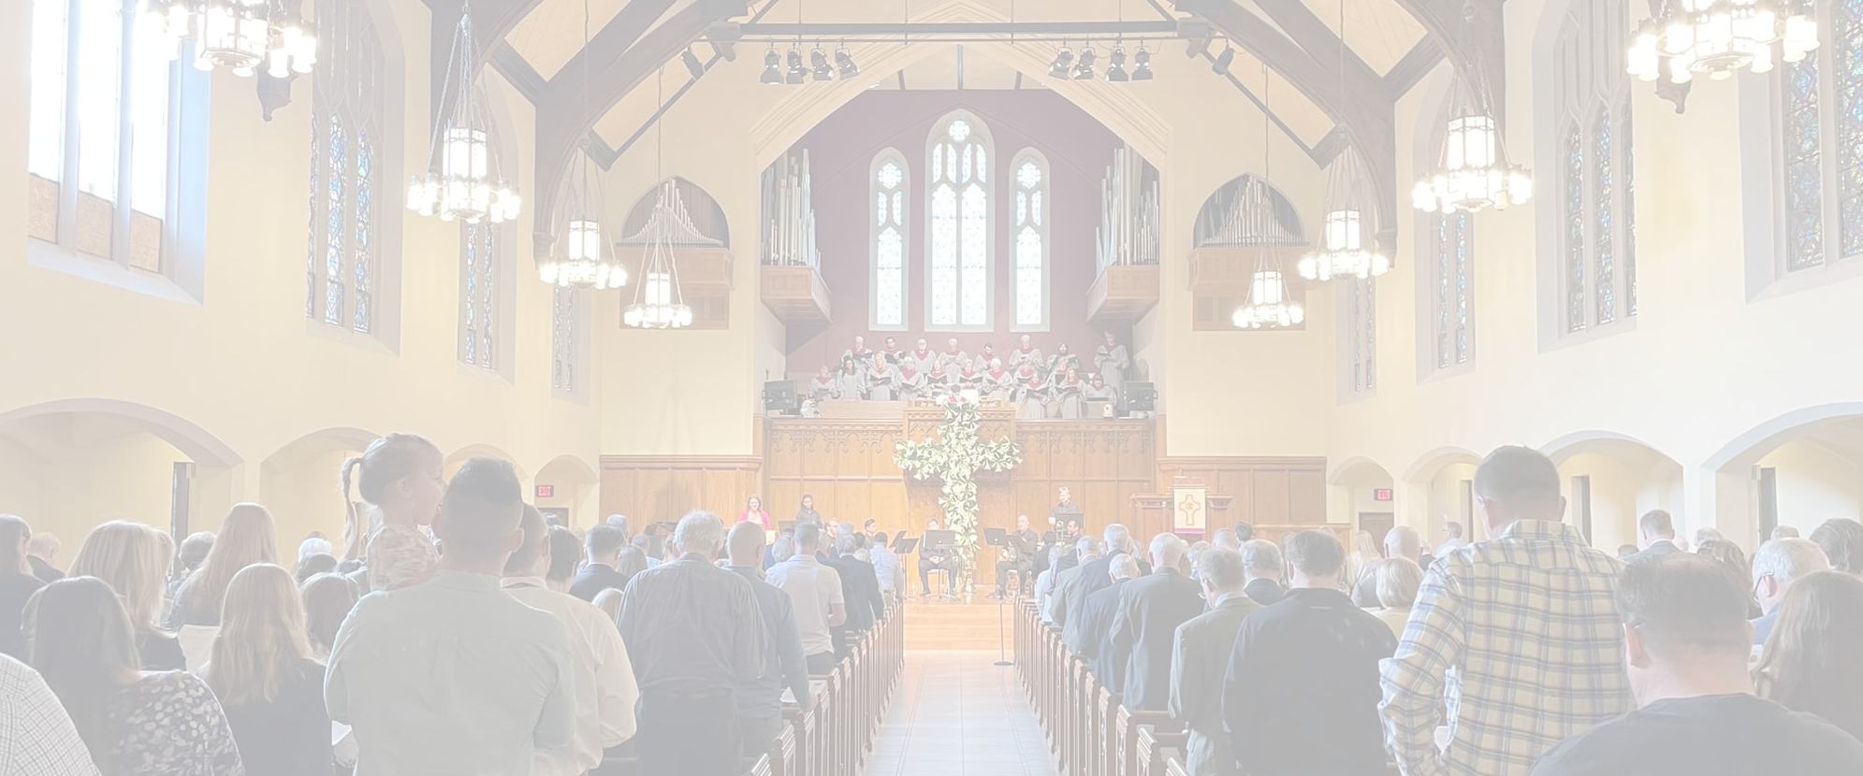



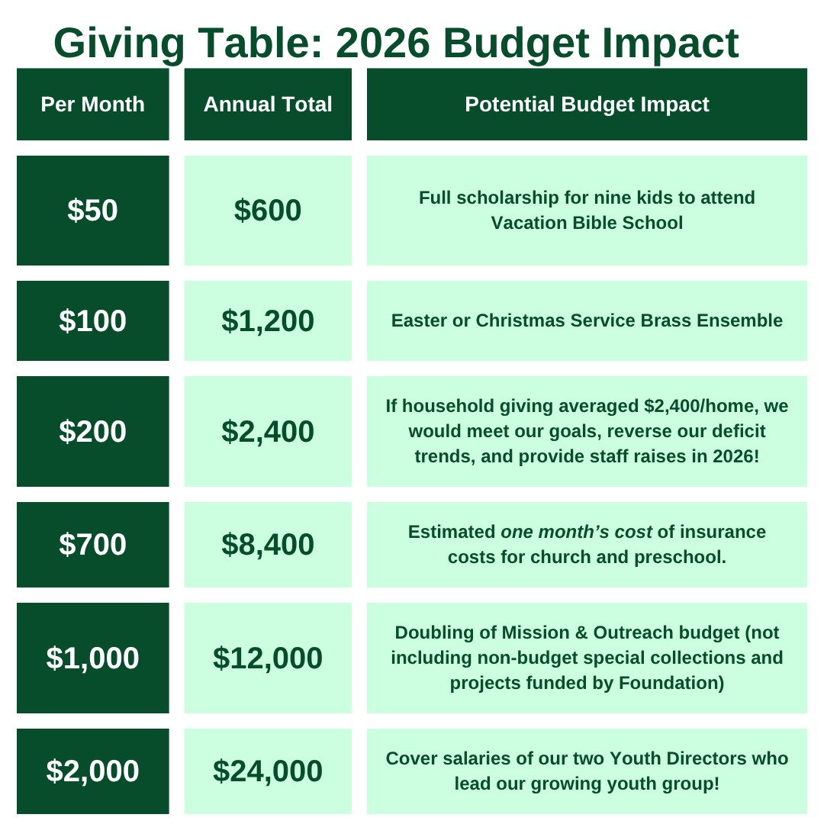

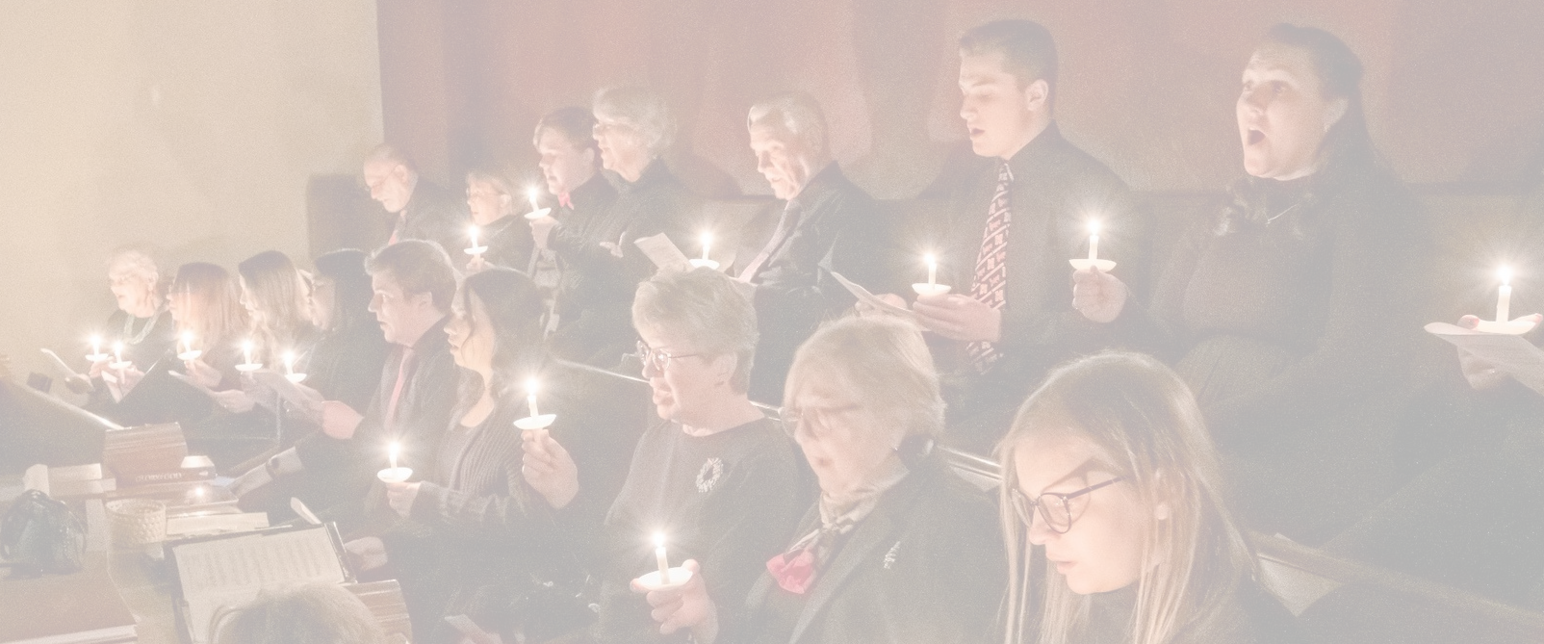
Giving F i nancial Gifts

Giving Time and Talents
When we use our time well, we act as good stewards of the gift of our days. You are invited to volunteer hands-on at Westminster or with Westminster service teams as we go and serve with community partner organizations. Please fill out the Time and Talents form, which is one part of the 2026 Pledge Form, and our committees will work to help you get plugged-in.
By sharing the gifts of our financial resources through a pledge commitment, we help equip the work of our church for the coming year. Our challenge for 2026 is for members and friends to either give for the first time, give again after a break, or give with an increase for those who are able. All pledge commitments to our 2026 Annual Giving Campaign make a difference.

2026 Annual Giving Campaign Westminster - L i ncoln
Grateful!


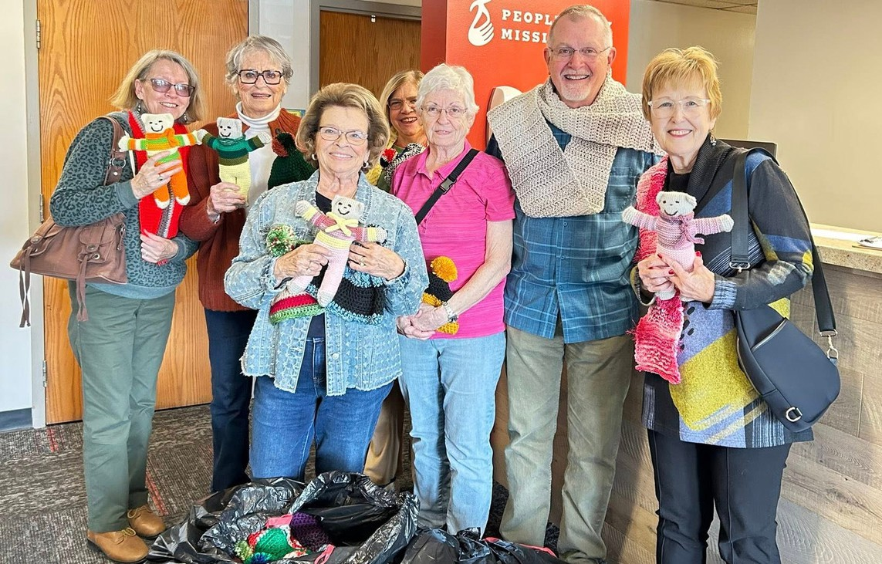
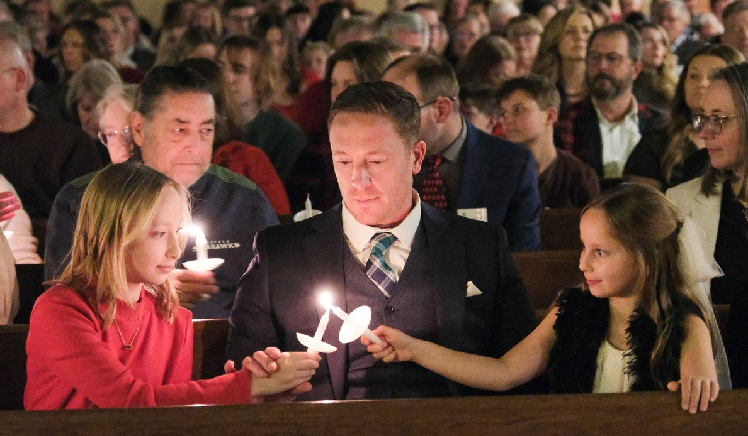
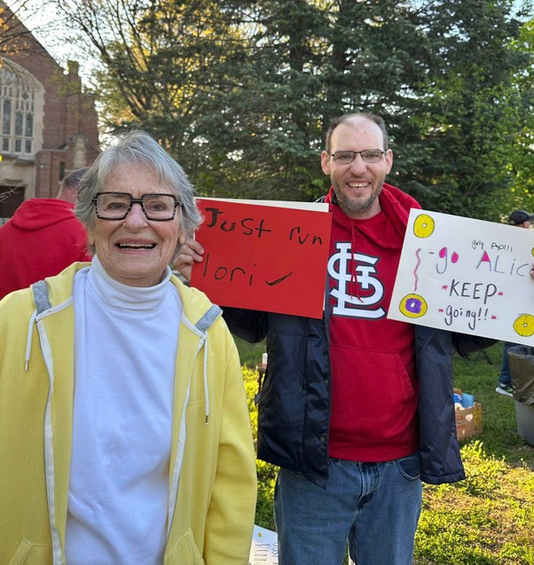
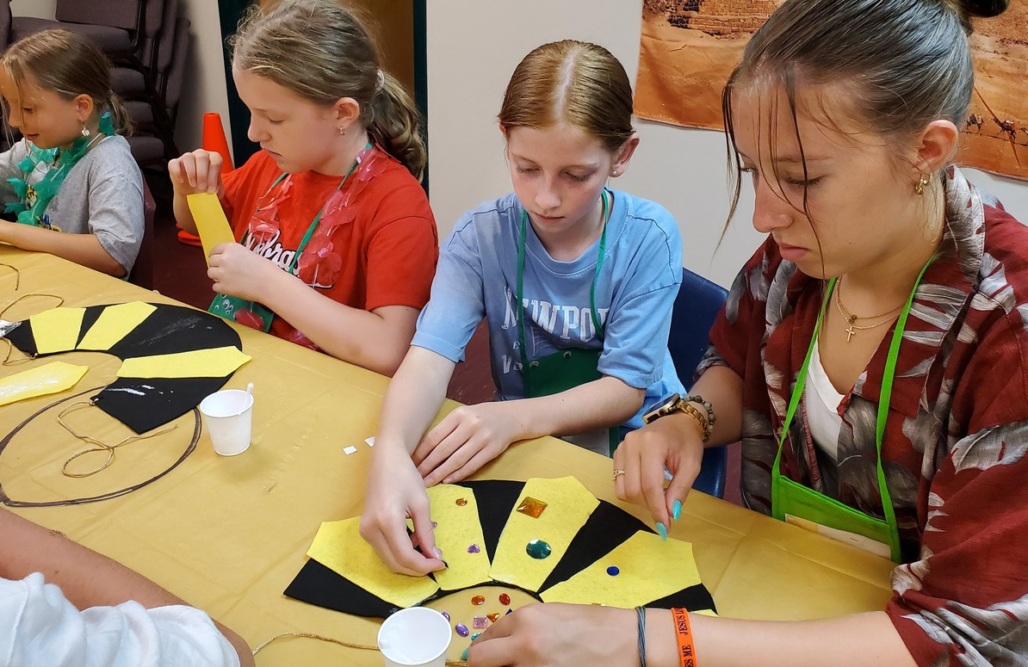
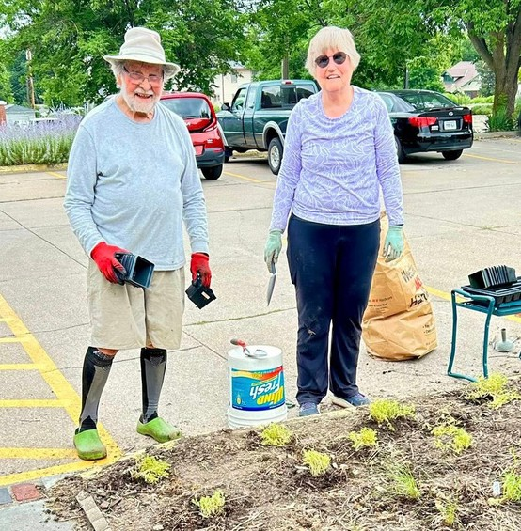
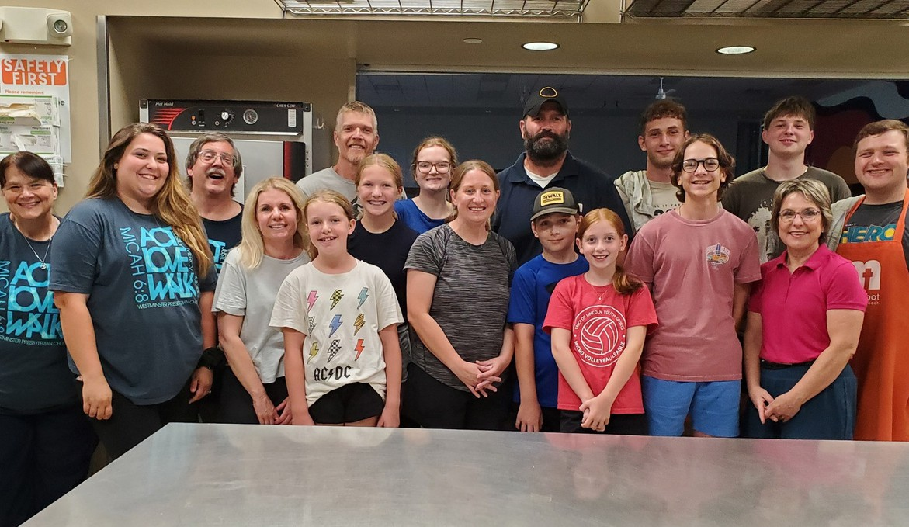
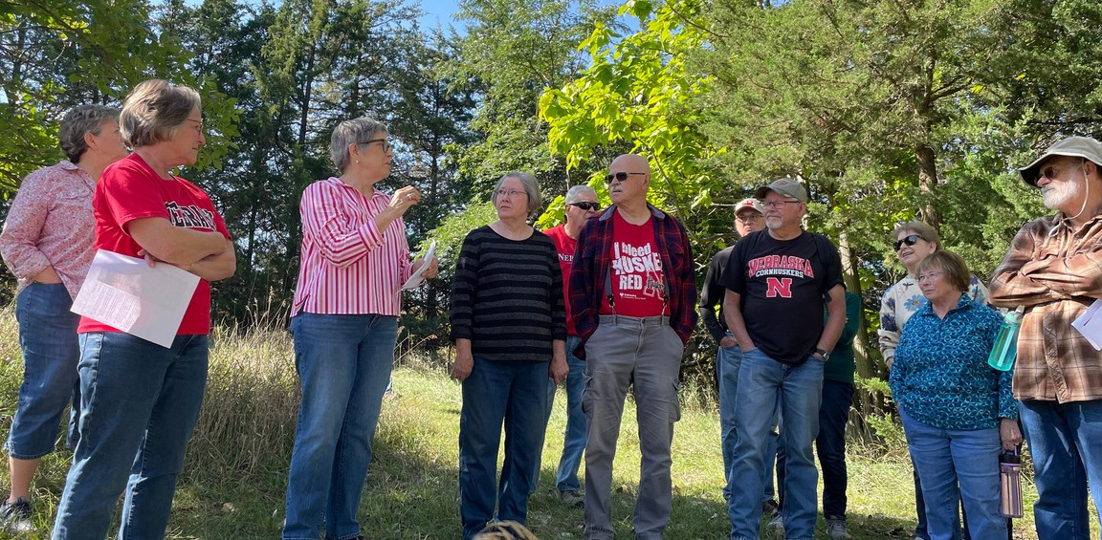
Westminster Friends,
There’ s a pret t y s imple t ruth we can all agree upon: we give because we are grateful . We give our t ime packing boxes in the Westminster Food Pantr y because we are grateful for our own access to food. We give our input in l i stening sessions with Ministr y Architects because we are grateful for WPC’ s past and excited for i ts future. We give our money to suppor t the wide- ranging work of Westminster as a church family because we know we are more the church God i s calling us to be with ever y member involved, ever y gif t of t ime shared, and ever y f inancial gif t of suppor t . This year our Giving Season’ s focus i s s imply, “ Grateful!” a word and a feeling that emphasizes our response to God’ s grace and goodness – with gratitude!
In 2025 , our Finance Commit tee has been c lear about the need for increased giving to suppor t our budgetar y needs. And, Westminster, you have responded! Our Session and staf f are “ Grateful!” for your increased suppor t .

Why Pledge to Give for 2026 ?
Where we have been: In December 2026 we will celebrate 100 years at Sheridan and South. For the upcoming year we will engage moments and memories f rom our past in celebration of our histor y and t radition.
Where we are now: Our youth program for 6 ^{t} ^{h} – 12 ^{t} ^{h}
graders i s at i ts highest engagement and par t i c ipation level s ince 2019 , and we are engaging children’ s ministr y with a renewed focus as par t of our Ministr y Architects
Consultancy Journey. Between staf f ing of one full- t ime
Director of Children & Youth and two par t - t ime youth leaders, a s ignificant space in Faith Village and the Youth Café that requires c leaning and heating/ cooling several t imes a week, and a robust program budget, 15 - 20 % of ever y dollar you give in 2026 goes toward Children & Youth Ministries ( and that doesn’ t include our large suppor t of Westminster Preschool)!
Where we are headed: 2026 will include an intensive
look at the usage of our facilities. This will be our year to shif t to a more positive v iew of seeing our buildings and grounds as a vessel for mission and ministr y rather than a f inancial hassle to keep up. To make that shif t , we have to not only maintain but also continually improve our facilities. Your giving suppor ts that renewed v i s ion and emphasis on welcoming and suppor t ing our neighbors for the next 100 years!

How to Give for 2026 …
Bring your completed Pledge Card and Time and Talent form to worship on November 16 ^{t} ^{h} , and place i t in the
basket during worship. You may also return i t to the
church of f i ce v ia the enclosed return envelope. Pledging before the end of the year allows us to plan well for a faithful, impact ful, and growth- focused 2026 !
You are encouraged by our Stewardship Team to consider “ The Power of 10 ” – increasing your giving in some way by 10 % this coming year.
I f you gave more in 2025 and can continue or increase that suppor t for future years, we hope you will increase your pledge to help us in a world where costs only go up year- to- year.
Help us meet our goal of growing Pledged Giving Income to $ 650 , 000 . I t ’ s a big goal, but as we heard in a recent sermon, a l i t t le faith can go a long way.
Westminster, let’ s give because we are grateful toward our faith l i fe together in 2026 !
With Gratitude,
Your Stewardship Commit tee
Rev. Chris Peters
Mrs. Sarah Baltensperger Mr. Dan Schaf e r

