Westminster Presbyterian Church
2110 Sheridan Blvd. Lincoln, NE
October 5, 2025
Season of Creation V

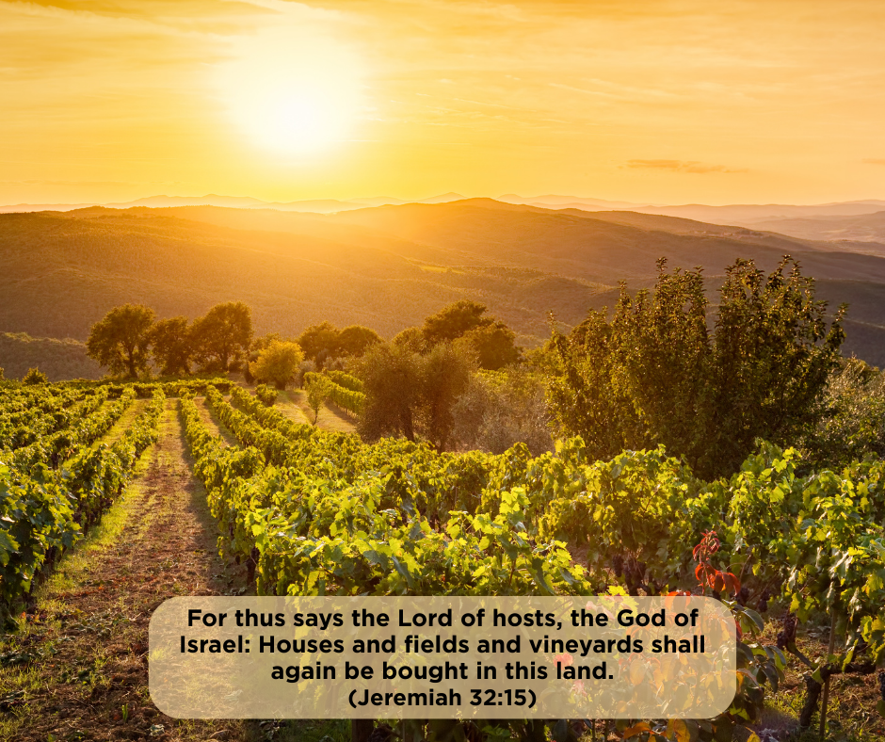

*Please rise in body or spirit for the parts of worship with an asterisk (*) before the title.
Parts of worship that are bolded and italicized are for all worshippers to read together aloud.

Prelude “All Things Bright and Beautiful” arr. Keith Kolander

Welcome Please sign and pass the friendship pad.

Special Announcement: Peace and Global Witness Offering Gary Haller
Financial Deficit Update Elder Jaime Hemmerling

*Call to Worship (adapted from 1 Corinthians 12) Elder Jaime Hemmerling
One: Come! Praise the Lord!
All: Praise God for the heavens and the earth and all that is in them!
One: Come! Praise the Lord!
All: Praise God who feeds the hungry and uplifts the downtrodden!
One: Come! Praise the Lord!
All: Praise God who gives sight to the blind and sets prisoners free!
One: Come! Praise the Lord!
All: The Lord will reign forever! Praise the Lord!

*Hymn #15 All Creatures of Our God and King

*Call to Confession Elder Jaime Hemmerling

*Prayer of Confession
Almighty God, you call us to lives of service, but we confess that we ignore our neighbors in need right outside our door. You call us to share our abundance, but we confess that we choose our own comfort over generosity to others. You call us to build community, but we confess that we are too often gatekeepers, letting in only the ones that make us comfortable. Forgive us, Lord. Help us to be content with enough and inspire us to share what we have – our prosperity, our power and our love – until all your children have life and dignity in the church community. We ask this in the name of Christ. Amen.

*Time of Silent Confession
Lord, hear our prayer. Amen.

*Assurance of Forgiveness
… Believe and share the good news!
In Jesus Christ, we are a new creation!

*Response of Praise #583 Glory to God
Glory to God, glory to God, glory in the highest!
Glory to God, glory to God, alleluia, alleluia!

*Passing of the Peace Rev. Chris Peters
Please share a sign of welcome and inclusion that is mutually comfortable (high five, handshake, fist/elbow bump) with your neighbors. At this time, children in K-5th Grade are invited to be dismissed to Faith Village, our children’s education time.
May the peace of Christ be with you. And also with you.
Sacrament of Baptism Zane Rehfeldt & Annelise Stelzer

The Study Catechism: Confirmation Version (Question 55)
One: What is baptism?
All: Baptism is the sign and seal through which we are joined to Christ.

Baptismal Affirmation by Congregation
Elder: Do you, the members of Westminster, promise to welcome Annelise and Zane, to walk with them in their faith and in their questions, and to be a friend in their journey with Jesus?
All: We do. Annelise and Zane, we welcome you with joy and hope, energy and enthusiasm, laughter and communion, nurture and faith, love and acceptance.

New Member Recognition
Elder: I invite you to welcome our new Westminster members using the printed words of welcome…
All: We welcome you to the Westminster church family, and pledge to support you in our shared worship, faith, and service together. With you we are more the church Christ is calling us to be!

Prayer for Illumination

Scripture
Hebrew Prophets Jeremiah 32:1-3a, 6-15 O.T. pg. 736
The Word of the Lord. Thanks be to God.

Sermon “People Reinvest” Rev. Chris Peters

Hymn #36 For the Fruit of All Creation

Prayers of the People / Lord’s Prayer Elder Jaime Hemmerling
Our Father, who art in heaven, hallowed be thy name; thy kingdom come, thy will be done on earth as it is in heaven. Give us this day our daily bread and forgive us our debts as we forgive our debtors, and lead us not into temptation, but deliver us from evil. For thine is the kingdom and the power and the glory forever. Amen.

Invitation to the Offering

Offering & Choir Anthem “All Things Bright and Beautiful”—John Rutter
This joyful anthem celebrates the beauty and diversity of God’s creation, making it a meaningful welcome for new members joining our church family and for pets we all love!

*Hymn #606 Doxology
Praise God from whom all blessings flow;
Praise God all creatures here below;
Praise God above ye heavenly host;
Praise Father, Son, and Holy Ghost. Amen.

*Prayer of Thanksgiving Rev. Chris Peters

*Hymn #365 God Reigns! Let Earth Rejoice!

*Charge & Benediction Rev. Chris Peters

Postlude “Let All Things Now Living” arr. Wayne L. Wold
---------------------------------------------------------------------------------------------------------
Today’s words for worship, or liturgy, are adapted from The Presbyterian Outlook Order of Worship for the 16th Sunday of Pentecost, September 28, 2025 by Rev. Rae Watson, Associate Pastor of Covenant Presbyterian Church, Staunton, Virginia.

Flowers are given by Glenna Haller, in honor of Presbyterian women.

Westminster welcomes and values children in worship. All kids and their families are welcome to pick up a Children’s Worship bag or blue Infant Bag in the Narthex (Sheridan Blvd. foyer). A nursery is available for kids under 5. If a parent feels a break is needed for their child during the service, our Infant Room is available at the north end of the Narthex.

Giving to Westminster’s Mission and Ministry

At Church: We have resumed giving through an offering in our worship service, leaning on the theology of offering as a response of gratitude to God’s word in worship. Checks may be made out to Westminster Presbyterian. General donations go to support the annual budget of the church, which includes Children/Youth support, staffing, building use, worship, and mission. You may also place an offering in our Giving Baskets following the service. These are located near the exits. Look for the baskets and signs that read “Giving Basket.” Ushers monitor the baskets and collect the offerings following the service. For online giving, scan the QR code.

Ministers: The whole congregation
Pastors: Rev. Chris Peters & Rev. Dr. Jimmy Shelbourn
Liturgist: Elder Jaime Hemmerling
Music Director: Wes Hansmeyer
Organist: John Ross
Director of Children & Youth: Trish Souliere
Greeters: Joyce Douglas & Janice Rohwedder
Ushers: Rohn Loyd, Becky Bockrath, Bruce & Margaret Sheffield
Dishwashers: Lisa & Steve McConnell
Sanctuary Audio & Livestream: Dale Minter & Stephan Biheng

