**Westminster Presbyterian Church**

2110 Sheridan Blvd. Lincoln, NE

**October 20, 2024**

**Twenty-Second Sunday after Pentecost**

**Everything Good About God is True II**

**Prelude**

**Welcome** Please sign and pass the friendship pad.

**\*Call to Worship** (inspired by Psalm 91:14-16; Common English Bible Translation)

One: God promises, ‘you are devoted to me, and so I’ll rescue you.’

***Many: God is good, and so God cares for us when we sing praises.***

One: God promises, ‘when you cry out to me, I’ll answer.’

***Many: God is good, and so we look for God to be with us in tough times.***

One: God promises, ‘I’ll fill you full with goodness in life and life everlasting.’

***Many: God is good, and so we hope in God’s saving love.***

One: Let us worship God with praise and singing!

**\*Hymn #1 *Holy, Holy, Holy! Lord God Almighty!***

**\*Call to Confession**

**\*Time of Silent Confession**

**\*Unison Prayer of Confession**

***God: Creator, Spirit, and Christ – no matter how hard we try to be faithful, we know we all fall short. We get so focused on ourselves that we forget to worship. We get so focused on our wants that we forget the tough times our neighbors face. We get so focused on what offends us that we forget to serve with joy. Forgive us, Holy One. Remind us that you share goodness, mercy, and love with us. Help us to follow Jesus, so we might share goodness, mercy, and love, too. Amen.***

**\*Response to Confession #437**

**You Are the Lord, Giver of Mercy!**

***You are the Lord, giver of mercy!***

***You are the Christ, giver of mercy!***

***You are the Lord, giver of mercy!***

**\*Assurance of Forgiveness**

Believe and share the good news!

***In Jesus Christ, we are a new creation!***

**\*Response of Praise #591**

**Halle, Halle, Hallelujah!**

***Halle, halle, hallelujah! Halle, halle, hallelujah!***

***Halle, halle, hallelujah! Hallelujah! Hallelujah!***

**\*Passing of the Peace**

*Because all ages are welcome to help with the service project, there will be no children’s chat or Faith Village today. Nursery is available.*

May the peace of Christ be with you. ***And also with you.***

**Prayer for Illumination**

**Scripture**

Gospel Reading Mark 10:35-45 N.T. pg. 47

The Word of the Lord. ***Thanks be to God.***

**Sermon** “A Few Words about the Spirit and Us” Rev. Chris Peters

**\*Hymn #727 *Will You Let Me Be Your Servant***

**\*Litany of What We Believe about Our Creator (From: PCUSA Brief Statement of Faith)**

One: In whom do we trust?

***All: We trust in God the Holy Spirit, everywhere the giver and renewer of life. The Spirit justifies us by grace through faith, sets us free to accept ourselves and to love God and neighbor, and binds us together with all believers in the one body of Christ, the Church…***

One: What else does the spirit do for us?

***All: In a broken and fearful world, the Spirit gives us courage to pray without ceasing, to witness among all peoples to Christ as Lord and Savior, to unmask idolatries in Church and culture, to hear the voices of peoples long silenced, and to work with others for justice, freedom, and peace.***

**Anthem** *God Has Work for Us to Do* (Mark Miller)

God has work for us to do

God has work for us to do

Til God’s will is done and all things are made new

God has work for us to do

**Lincoln Hygiene Network Kit-Making**

**Prayers of the People and Dedication of Kits**

**The Lord’s Prayer**

***Our Father, who art in heaven, hallowed be thy name; thy kingdom come, thy will be done on earth as it is in heaven. Give us this day our daily bread and forgive us our debts as we forgive our debtors, and lead us not into temptation, but deliver us from evil. For thine is the kingdom and the power and the glory forever. Amen.***

**\*Hymn #301 *Let Us Build a House (verses 1-2, 4-5)***

**Charge and Benediction**

-------------------------------------------------------------------------------------------------------------------

*Please rise in body or spirit for these parts of worship.

Today’s words for worship are gathered and adapted by Pastor Chris from the following resources: *Where the Broken Ones Gather: Lectionary Liturgies for RCL Year B* by Rev. Thom M. Shuman for our prayer of confession, Presbyterian Outlook Order of Worship Oct 20 for select responses, *the PC(USA) Book of Confessions: A Brief Statement of Faith* for our Litany of What We Believe. The Call to Worship is inspired by the Psalm of the day, Psalm 91:14-16, from the Common English Bible translation.

**Giving to Westminster’s Mission and Ministry**

***At Church***: An offering to support Westminster may be placed in our Giving Baskets following the service. Look for the baskets and signs that read “Giving Basket.” Ushers monitor the baskets and collect the offerings following the service.

***For online giving*,** scan the QR code.

**Ministers:** The whole congregation

**Pastors:** Rev. Chris Peters & Rev. Dr. Jimmy Shelbourn

**Interim Music Director:** Dr.Mary Young

**Organist:** John Ross

**Director of Children & Youth:** Trish Souliere

**Greeters:** Joyce Douglas & Marilyn Hood

**Ushers:** Leslie Miner, Tom Welstead, Barb Andersen, Marijane England

**Dishwasher:** H & Judy Seward

**Sanctuary Audio and Livestream:** Dale Minter

*“I am the vine,*

*you are the branches . . .”*

**The week of Oct. 20, 2024**

*Westminster Presbyterian Church is an inclusive faith family, inspired by Jesus Christ, to call, nurture, and empower disciples.*

**Westminster “Service of Service” II**

**Today, at 9:30 AM, Westminster Gym**

A combined time of worship and congregational service project.

This year’s project will be packing Travel Hygiene Kits for distribution by Lincoln Hygiene Network to neighbors in Lincoln experiencing homelessness and housing insecurity. Let’s work together to complete 1,000 kits!

A worship and sermon series reminding us of the goodness of God and our active role in God’s world!

“A better story of faith exists, and it has the capacity to heal the world—if we only embrace, articulate, and live it more couragously.” Rev. Bruce Reyes-Chow, author and pastor, will be teaching and preaching at Westminster on Nov. 9 & 10.

Sunday 10/20 – A Few Words about the Spirit and Us

Sunday 10/27 – A Few Words about Jesus and Us

Sunday 11/3 – A Few Words about the Good News and Us

Saturday 11/9 – Community-Wide Event featuring Rev. Bruce Reyes-Chow, Author and Pastor (9:30 AM – 2 PM at Westminster)

Sunday 11/10 – Rev. Bruce Reyes-Chow preaching and leading Adult Education hour at Westminster

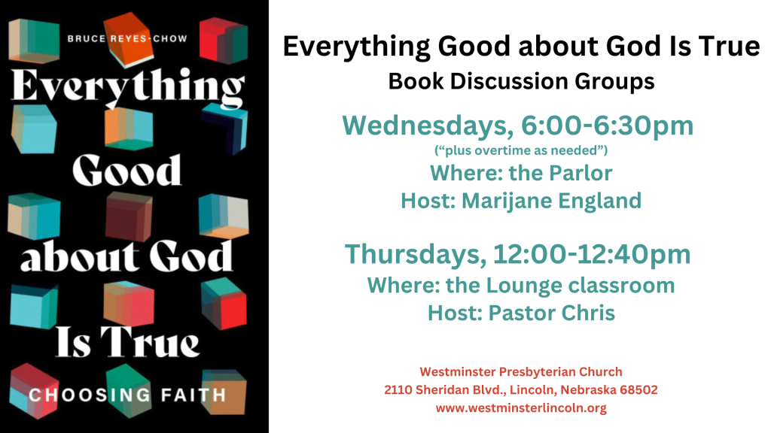

**Adult Ed schedule**

Oct. 20: No Adult Ed., Service of Service, packing kits for Lincoln Hygiene Network.

Oct. 27: “Cathedrals, Abbeys, and Kirks” by Rev. Jimmy Shelbourn, stories of the Reformation in Britain.

**Position Open at Westminster**

Westminster is looking for a part-time Communication and Administration Coordinator—22 hrs./wk. The position description is on the website—westminsterlincoln.org. To apply: Send cover letter and resume to [office@westminsterlincoln.org](mailto:office@westminsterlincoln.org).

**There’s Still Time…**

toadd more personal care products to the **barrel** by the east entrance steps. **Presbyterian Women** in partnership with the Lincoln Hygiene Network will end the Westminster 2-month collection on **OCTOBER 31.** Let’s top off the project with one more toothbrush, one more bar of soap, or one more monetary donation to lincolnhygienenetwork.org. For all the products and the self-worth and dignity of the receivers, we give our gratitude to God and to all of you who have participated. We will update on the final number of items soon.

***PRESBYTERIAN WOMEN Do Everything in LOVE***

**Could you take a turn?**

We are still in need of dishwashing volunteers for the third and fourth Sundays of the even numbered months. Step up and help Westminster fulfill our pledge to be “green.”

**Spooktacular | October 30**Spooktacular is coming soon, and we need your help! There are two main ways you can contribute.

1. First, we are looking for donation bags of candy, crackers, packaged snacks, and/or any small handouts for our stations to distribute to the children.
2. Or, if you are feeling more adventurous and creative, consider hosting a trunk of your own.

If you can host a trunk or have questions, contact Sarah Baltensperger at [**sarah.baltensperger@gmail.com**](mailto:sarah.baltensperger@gmail.com)or Stacy Graham at[**babyruth19@hotmail.com**](mailto:babyruth19@hotmail.com)**.**

**Daylight Savings Time** ends the first weekend in November. Turn your clocks back an hour before you get up on Sunday morning or you’ll be early for church.

**Bible Study on Environmental Justice**

October’s Environmental Justice action is centered on reverence for the land.  Sometime this month go outside and treat yourself to twenty minutes of experiencing gratitude and awe.  And if it feels good, tell someone about it.

**Photographic Artwork Exhibit**

Dale Minter will be exhibiting some of his photographic artwork in the hallway going from the garden room to the main sanctuary in the coming weeks. Please feel free to explore the visual journey.

**Landscaping Sign-Up**

This is the link to sign-up to do a project that will beautify the church grounds—[**https://t.ly/AF00-**](https://t.ly/AF00-)**.** Your help is needed and appreciated. Questions? Contact Gary Haller (817-757-2980) or Tom Pappas (402-202-4454).

**Week Beginning Oct. 20**

|  |  |
| --- | --- |
| **Sun. (Oct. 20)**  9:30 AM Service of Service for Lincoln Hygiene Network, Gym  12 Noon Sudanese Worship  **Mon. (Oct. 21)**  11 AM Explorers Bible Study, Library  3:30 PM UNL Choir Rehearsal, Sanctuary  **Tues. (Oct. 22)**  5:30 PM Deacons, Lounge  **Wed. (Oct. 23)**  1:30 PM Hearts and Hands, Library  3:30 PM UNL Choir Rehearsal, Sanctuary | 6 PM W3 (Welcome to Westminster on Wednesdays), FH  6 PM Reading Group, Bruce Reyes-Chow Book, Parlor  6:30 PM Choir Rehearsal, Sanctuary  **Thurs. (Oct. 24)**  12 PM Reading Group, Bruce Reyes-Chow Book, Lounge  7 PM Lincoln Continentals Rehearsal, Sanctuary  **Sun. (Oct. 27) Reformation**  9:30 AM Worship, Faith Village  10:45 AM Adult Ed, Lounge  12 Noon Sudanese Worship |

**Worship services are available on-line at this link:**

<https://www.youtube.com/@WestminsterLincoln/streams>

[joanne@westminsterlincoln.org](mailto:joanne@westminsterlincoln.org) 402-475-6702