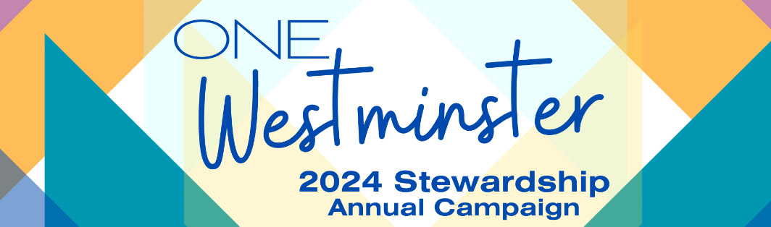

Pledge Commitment Form for 2024 Annual Campaign
“One God, One-in-Christ, One Westminster – All with Gratitude!”
(Time and Talents on Reverse)

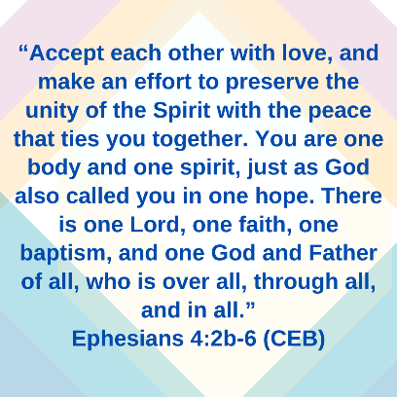
Name: ________________________________________________
Phone: ________________________________________________
Email: ________________________________________________

2024 Budget “Annual Campaign” Pledge
What: I have reviewed Westminster’s 2024 Storytelling Budget and goal letter. Below is the amount our household commits, or “pledges” to give in 2024:
Pledge Commitment: $______________

With this Pledge Commitment I am showing gratitude to God with…
___ A first-time or new annual commitment to Westminster for 2024!
___ An increased commitment of $_____ per (circle one): week / month / year above 2023.
___ An increased commitment of _____ % above 2023.

How will you give?
___ I intend to fulfill my Giving Commitment by giving each (circle one):
Week Month Quarter Year
___ I intend to submit a matching gift form to my employer.
___ I intend to pay by automatic withdrawal from my checking/savings account.
___ I intend to pay by credit card / online.
(https://onrealm.org/westminsterlincoln/-/form/give/now)

Regardless of how you will give, please bring your Commitment Form to worship
on Commitment Sunday, November 5, 2023 or submit to:
Westminster Presbyterian Church (c/o Dennis Rohren, Bookkeeper)
2110 Sheridan Blvd, Lincoln, NE 68502
-----------------------------------------------------------------------------------------------------------------------------------------
“Per Capita” – Another Opportunity to Give
What: Per Capita is a per-member amount Westminster pledges and pays from our budget to higher councils in the Presbyterian Church (U.S.A.) structure. Examples of how Per Capita is used include presbytery (Lincoln and nearby towns) support for grants to churches for mission projects, Synod (NE, MN, IA, SD, ND) support for Synod School scholarships to families in need, and General Assembly (“national / international”) support for Presbyterian Disaster Assistance, hosting our denomination’s bi-annual General Assembly, and the growth of 1,001 New Worshipping Communities. Simply fill out an amount below if you will give to offset this amount in our annual budget.
Per-Capita Commitment: $46.00 X _____ # of members = __________ Total
2024 Westminster Time and Talents Form
(One Westminster Pledge Commitment Form on reverse!)

Instructions: Please fill out this form as a household. A committee chair or member will reach out to you regarding any selections and you may clarify who to contact, if different, at that time.

Name(s) in Household: ___________________________________________ Date Completed: __/__/___
Preferred Contact for form follow-up: (Phone or Email): ____________________________________________

Prior Service: _________________________________________________________________________
__ I am a PC(USA) Elder (active or inactive) __ I am a PC(USA) Deacon (active or inactive)

Future Service Interests or Current Areas of Service and Involvement
Building and Grounds (WPC Property)
__ Committee Member __ Church Grounds Clean-Up/Maintenance
__ Building Projects/Skilled Volunteering __ I am interested in learning more about this area.

Christian Education and Nurture
__ Children’s Education Committee Member __ Adult Education Committee Member
__ Nursery Volunteer __ Adult Ed Facilitator or Leader
__ Kid’s Education (Faith Village) Leader __ I am interested in learning more about Adult Education offerings.
__ Youth Advisor / Volunteer Leader __ I would like to receive updates for: Children ___ Youth ___
__ Children’s Chat Leader (in Worship) __ Presbyterian Women

Church Life / Ministries of Care
__ Committee Member __ Sunday Morning Greeter (at Entrance)
__ New Member Engagement __ Washing Dishes (after Coffee Hour or other events)
__ Assisting or Planning Church Events __ Visitor Outreach or Connection
__ Front Desk Volunteer (Phones/Welcome) __ “Cook and Carry” Meal Outreach
__ Funeral Reception Assistance __ Hospital or Homebound Visitation

Communications Task Force
__ Committee Member __ Photography of Events
__ Assist with Audio/Visual or Setup for Events __ Media Liaison: Write, Edit, and/or share info with LJS.
__ Help Livestream Church Services/Events __ I have another interest in this area and would like to be contacted.

Finance and Stewardship
__ Stewardship / Pledge Drive Support __ Special / Capital Campaigns
__ Budgeting __ I have another interest in this area and would like to be contacted.

Mission and Outreach
__ Committee Member __ Mission Trips (Circle): Regional / National / International
__ Serving Meals with Partner Orgs __ Habitat for Humanity (Home Building / Repair / ReStore)
__ Green @ Heart (Creation/Earth Care) __ WPC Food Bank Volunteering
__ Presbyterian Disaster Assistance __ I have another interest in this area and would like to be contacted.

Welcoming Task Force
__ LGBTQIA+ Inclusion at WPC __ Racial Equity and Inclusion
__ Accessibility and Differing Abilities __ I have another interest in this area and would like to be contacted.

Worship and Music
__ Committee Member __ Helping with Worship Decoration (Hanging of the Greens, etc.)
__ Choir / Music Interest __ Liturgist (Reader in worship service.)
__ Sunday Morning Usher __ I have another interest in this area and would like to be contacted.

Other
__ I am interested in serving, getting involved, or learning more about another area. Or, I have particular experience or gifts I would like WPC to know about. (Please share below)
_______________________________________________________________________________________________________________________________________________________________________________________________________________

