2022 Poinsettia Donation Form
Share the joy of Christmas! This year we will be ordering poinsettias to place in the sanctuary for the Christmas Eve services. You can make a donation in memory or in honor of a loved one, to be included in the bulletin for Christmas Eve.

The donation level is $15. Please make checks payable to Westminster and write POINSETTIA on the memo line. Donations must be received by Dec. 13 to be included in the order of worship. There is also an option to donate to the Westminster Library.
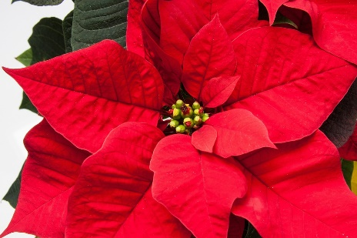
Mail your check and the information specified below to:
Westminster Presbyterian Church
Attn: Joanne
2110 Sheridan Blvd., Lincoln, NE 68502

____ I would like to donate $________ toward the purchase of poinsettias.

____ I would like to donate $________ to the Westminster Library.

Given by:

______________________________________________________________________________________

In memory of:

______________________________________________________________________________________

In honor of:

______________________________________________________________________________________

Amount enclosed: $___________

