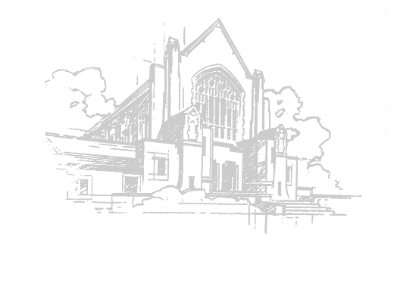
Westminster Presbyterian Church
2110 Sheridan Blvd. Lincoln, NE
December 20, 2020
Fourth Sunday of Advent

Prelude John Ross, organ

Welcome Rev. Chris Peters
The Lord be with you.
And also with you.

Minute for Mission: Christmas Joy Offering Steve Hughes

Call to Worship (from Psalm 89:1-2) Deacon Michael Gregg
One: I will sing of your steadfast love, O Lord, forever;
All: With my mouth I will proclaim your faithfulness to all generations.
One: I declare that your steadfast love is established forever.
All: Your faithfulness is as firm as the heavens.

Advent Wreath Candle Lighting Mattie McIntosh & Henry Sipp

*Hymn #107 Awake! Awake, and Greet the New Morn

Call to Confession

Prayer of Confession (unison)

Individual Silent Prayer
God of love, as we come to know your love, we seek to be faithful in all parts of life. Yet, we fall short of responding to and sharing your love. We accept lies as truth from leaders. We accept fear as an excuse from loved ones. Illumine the way of love for us, O Lord. Renew our hearts and minds. Shape our lives in the image of your love. Let us seek justice, love kindness, and walk humbly with you all of our days. With hope in Christ, we pray. Amen.
Response to the Confession
#88 O Come, O Come, Emmanuel v. 7
O come, Desire of nations, bind all peoples in one heart and mind;
Bid envy, strife, and discord cease; fill the whole world with heaven’s peace.
Rejoice! Rejoice! Emmanuel shall come to thee, O Israel

Assurance of Forgiveness
In Jesus Christ, we are a new creation!

*Response of Praise
#121 O Little Town of Bethlehem v.4
O holy child of Bethlehem, descend to us we pray;
Cast out our sin and enter in; be born in us today.
We hear the Christmas angels the great glad tidings tell
O Come to us, abide with us, our Lord Emmanuel.

Children’s Message Rev. Chris Peters

Special Music

Prayer for Illumination

Scripture
Gospel Luke 1:26-45
Holy Words to awaken us. Thanks be to God.

Sermon “Those Who Dream… Are Not Alone” Rev. Chris Peters

*Hymn #372 O For a World

Prayers of the People Deacon Michael Gregg
The Lord be with you.
And also with you.
Lift up your hearts.
We lift them to the Lord.
Let us give thanks to the Lord our God.
It is right to give our thanks and praise.

The Lord’s Prayer
Our Father, who art in heaven, hallowed be thy name; thy kingdom come, thy will be done on earth as it is in heaven. Give us this day our daily bread and forgive us our debts as we forgive our debtors, and lead us not into temptation, but deliver us from evil. For thine is the kingdom and the power and the glory forever. Amen.

Moment of Gratitude

*Charge & Benediction

Postlude John Ross, organ

